Chapter 2 Questions 6, 15, 25 Michael Streyle

##   
## Call:  
## lm(formula = Breakage ~ Transfers)  
##   
## Coefficients:  
## (Intercept) Transfers   
## 10.2 4.0

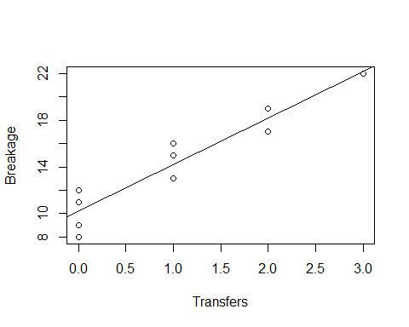

## [1] 2.306004

## [1] 0.05394531

##   
## CONFIDENCE LIMITS FOR INTERCEPT AND SLOPE:

## 2.5 % 97.5 %  
## (Intercept) 8.670370 11.729630  
## Transfers 2.918388 5.081612

##   
## HYPOTHESIS TESTS FOR INTERCEPT AND SLOPE:

## Estimate Std. Error t value Pr(>|t|)  
## (Intercept) 10.2 0.6633250 15.377079 3.178273e-07  
## Transfers 4.0 0.4690416 8.528029 2.748669e-05

##   
## CONFIDENCE LIMITS FOR INTERCEPT AND SLOPE:

## 1.25 % 98.75 %  
## (Intercept) 8.374846 12.025154  
## Transfers 2.709421 5.290579

##   
## CONFIDENCE INTERVAL FOR A MEAN RESPONSE at Transfers = 2 or 4:

## fit lwr upr  
## Transfers=2 18.2 15.97429 20.42571  
## Transfers=4 26.2 21.22316 31.17684

##   
## PREDICTION INTERVAL FOR AN INDIVIDUAL RESPONSE at Transfers = 2:

## fit lwr upr  
## 1 18.2 12.74814 23.65186

##   
## PREDICTION LIMITS FOR THE MEAN OF 3 NEW OBSERVATIONS at Transfers=2:

## fit lower upper  
## 1 18.2 15.15908 21.24092

##   
## PREDICTION LIMITS FOR THE TOTAL OF 3 NEW OBSERVATIONS at Transfers=2:

## fit lower upper  
## 1 54.6 45.47724 63.72276

##   
## WORKING-HOTELLING CONFIDENCE BAND (LIMITS) at Transfers = 2 or 4

## fit lower upper  
## 1 18.2 15.44116 20.95884  
## 2 26.2 20.03104 32.36896

##   
## ANOVA TABLE:

## Analysis of Variance Table  
##   
## Response: Breakage  
## Df Sum Sq Mean Sq F value Pr(>F)   
## Transfers 1 160.0 160.0 72.727 2.749e-05 ***  
## Residuals 8 17.6 2.2   
## ---  
## Signif. codes: 0 '***' 0.001 '**' 0.01 '*' 0.05 '.' 0.1 ' ' 1

## DF Sum Sq  
## Corr. Total 9 177.6

## [1] 5.317655

##   
## R SQUARED:

## [1] 0.9009009

##   
## CORRELATION COEFFICIENT:

## [1] 0.949158